Luminary Micro DesignStellaris2006 Entry
Registration Number LM1770
Stellaris microcontroller: LM3S811

Copyright 2007 by Chuck Baird
http://www.cbaird.net
All rights reserved
All code may be freely used

Recycling Binary Trees
Complete Documentation

Description of Project

Overview
This entry describes and demonstrates an algorithm for the efficient recovery and reuse of memory resources allocated to data structures known as binary trees. Entire subtrees may be reclaimed by the garbage collection system in a single interaction without subtree traversal. Subsequent requests for new nodes efficiently extract individual nodes from recycled subtrees as appropriate.

As a demonstration of the algorithm, and as a means for the author to have an excuse to play with the Stellaris LM3S811 Evaluation Kit, an application with a graphical output was designed and implemented. A small (63 node, 5 level) binary tree is constructed and modified randomly, with a graphical representation being displayed in real time. Of course this choice of microcontroller is extreme overkill for this application, but the algorithm is applicable to any implementation of binary trees where garbage collection and reallocation of discarded nodes is desired.

Binary Trees
A binary tree is a data structure wherein information is organized into groupings called nodes, with each node being capable of branching to a maximum of two child subtrees, each of which is also a binary tree. With the exception of some method of reference to the child nodes, the interpretation of the contents of nodes is user defined. Nodes without children are called leaves, and the top node (the one without a parent node) is called the root, or head, of the tree. The nomenclature comes from the structural similarity (within the twisted asocial minds of software people anyway) to real-world trees, while the word binary refers to the maximum of two child subtrees per node.

Graphically a binary tree is typically show with the root at the top, and the nodes and leaves projecting downward. Figure 1 shows a simple binary tree with node contents as might be used for alphabetic searching. Starting at the root, a target value is compared to the node value, and the comparison proceeds to the left child or right child subtree depending upon the results of the comparison. The process repeats until a match is found, or a desired subtree branch does not exist.

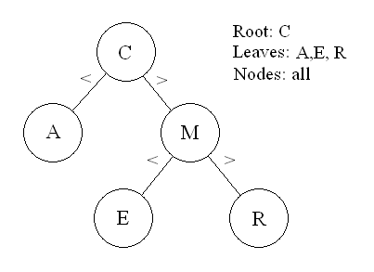
Figure 1: Simple binary tree for alphabetic searching

Binary trees are used in a variety of computer science applications, including sorting and searching algorithms, hash codes, puzzle and game playing, Huffman code determination, artificial intelligence applications, expression evaluation, and the like. They are about the simplest of the nonlinear data structures, and one of the first interesting things encountered by beginning students in computer science.

Node Allocation
Nodes require memory, at least enough to specify (whether they exist or not) the two child branches. Typically this will be done using pointers, although in some cases or languages it may be implemented as subscripts of arrays or structures or in some other manner. In some cases the maximum size of a tree (the number of nodes required) is known in advance, while in others the tree grows dynamically, requiring memory for nodes to be obtained from the system during runtime.

For many applications which employ binary trees, the tree is constructed, utilized, and then discarded in total. Once a node is added to the tree it stays there until the tree has outlived its usefulness. Other types of applications build and dynamically modify the tree, freeing up nodes which are no longer needed and adding new ones. It is this second class of applications that can best use the algorithm described here.

Memory for nodes can be obtained initially or, in many languages, dynamically during runtime. If, in C for example, runtime memory for individual nodes is obtained via malloc(), it can be individually released back to the system as each node is no longer needed. This system interaction has a certain overhead, however, and it may be preferable to obtain blocks of memory large enough for several, perhaps even hundreds or thousands, of nodes at one time. Such a block of memory cannot be released back to the system until all nodes within it are inactive, so a method of recycling node memory within the application is often desirable. Likewise, if the application language does not support dynamic memory allocation during runtime, garbage collection and reusing node memory may be required if the binary tree can change and grow, especially with large trees or limited memory resources.

The advantage of this algorithm is that entire subtrees can be recycled without the overhead of traversing the subtree and relinquishing or otherwise inspecting each node within it individually. A node (which may or may not have attached children and subtrees) is handed off to the garbage collection function intact. The node allocation function later efficiently extracts individual nodes from any subtrees it may be managing, thus totally bypassing the usual problems of dismantling a tree to dispose of it.

Disclaimer
To the best of the author’s knowledge, this algorithm is original with him. He first derived and coded it in about 1971 and has used it in several applications since then. He has never seen a similar technique described. That being said, however, there is probably no single area of computer science about which more has been written, said, or done (with more being said than done, of course) than binary trees. This algorithm is not rocket science, but merely the application of common sense to an obvious problem. It would be amazing if someone else has not elucidated the ideas behind this algorithm, but, as stated, the author is unaware of such.

This demonstration program, of course, is strictly for show and has no practical use whatsoever other than being an excuse to light up some pixels and play with the button and thumbwheel on the evaluation kit. And to try out the C compiler, of course. The application is merely the corn chip upon which the salsa of the algorithm may be tastefully and tastily fed to the (the author is sure) eagerly awaiting reader.

The Source of Node Memory
The algorithm consists of two components, a node dispenser and a garbage collector. Initially both are empty; that is, there are no nodes available to be handed out and nothing has been collected for recycling.

As an alternative the application can predefine (in terms of memory allocation) some set number of nodes and have them available for dispensing. This would most likely be the case if the maximum node count were known in advance or the application were written in a language that did not support dynamic memory allocation. For the following discussion it will be assumed that the language is C, that pointers are used, that dynamic memory allocation is available, and initially no nodes are allocated.

When the application calls the node dispenser the first time, there are no nodes available and no memory in which to build nodes, so it calls malloc() to request a block of memory (the size of which to be determined by either predefined literals or variables). If the memory block is not available, the function returns an error. If it is available, the function divides the block into nodes and puts them into the garbage pool, returning one to the caller.

Subsequent requests dispense these nodes, but if they run out the malloc() allocation process repeats. The application may have adjusted the default allocation block size in the interim, depending upon its insight and wisdom into likely usage patterns and needs.

So, one part of the node dispenser is a mechanism for obtaining fresh memory as needed, while the other part redispenses nodes than have been returned via the garbage collector.

Garbage Collection
The garbage collector maintains a linked list, initially empty, of returned nodes. There is a variable (here called Head) which is null or points to the first node in the linked list. Returned nodes are linked to the head of the list. The returned node may be a single node, or it may be a subtree (that is, it may have child nodes). Through a union of structures the linked list pointer for the garbage list overlays part of the data area of the node as shown in Figure 2.

To link a returned node into the list, the current value in Head is copied to the node’s data area pointer, and the pointer to the returned node is stored in Head. Whether the returned node has children or not makes no difference.

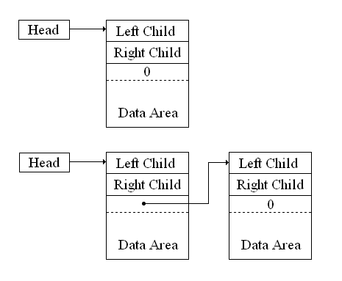
Figure 2: Before (top) and after (bottom)
returning a node to the garbage pool

Figure 2 does not show the child nodes, nor their children, etc. Returning a single node to the available pool can actually make any number of nodes potentially available. The fun begins with the next request for a node allocation.

Node Dispensing
There are 9 different cases to be considered for an allocation request. The first we have already seen, and that is when Head = 0 (a null pointer). That means there are no nodes in the garbage pool, and space for a predetermined number of nodes is obtained from the system. The nodes are linked into the list, and are thus available to be dispensed.

The other 8 cases have at least one node linked to the Head pointer as shown in Figure 2. If you consider the Left Child pointer, the Right Child pointer, and the Next pointer to be zero (null pointers) or nonzero (pointing to another node), there are 2³ or 8 combinations.

In each of these 8 cases the node allocation function will always return a pointer to the first node (that is, the value in Head is returned). In other words, the node at the front of the list gets reused first. The tricky part is to determine which node we will then point Head at next.

If all three pointers are zero, the linked list consists of a single node with no children. As always, a pointer to that node is returned, and Head is set to null indicating the pool is empty.

There are three cases where only one of the three pointers is nonzero, as shown at the top of Figure 3. In each case that nonzero pointer is copied to Head, thus moving its target to the front of the list. If it is one of the child pointers (as opposed to the pointer in the data area of the node), then the pointer in the data area of that child node needs to be set to zero. Figure 3 will help clarify this point.

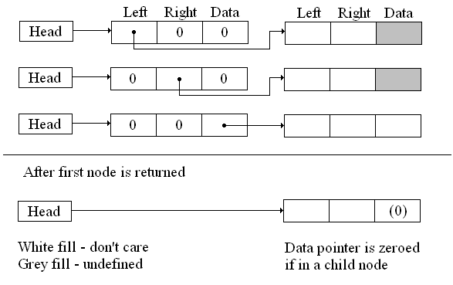
Figure 3: Before and after returning first node
when there is one nonzero pointer

Notice the grey fill in the first two cases in Figure 3. These represent child nodes attached to the node at the front of the garbage list, and as such their data areas are unchanged from when they were active nodes. There is not a valid pointer in those data areas, so if one of them is elevated to the front of the list, the pointer field in its data area must be set to null. In the third case, where the second node is not currently a child, the pointer in the data area will have been filled in previously and we must leave it as it is.

In the next three cases two of the three pointers are nonzero, and one is zero. Figure 4 shows the three possible situations before the node pointed to by Head is returned by the allocation function.

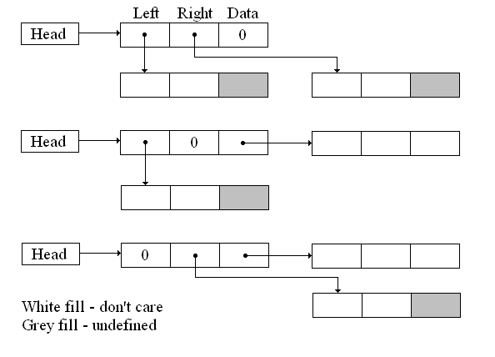
Figure 4: Before returning the first node
where there are two nonzero pointers

Again, in Figure 4 the nodes with the shaded data areas are child nodes where the data areas have not been initialized with a valid pointer. The nodes with the white filled data areas do have valid pointer values in them, although it doesn’t matter at this point what those pointer values are.

The algorithm for the case with two nonzero pointers is to return the current value of Head as the newly assignable node, and to replace the value of Head with the first of the two nonzero pointers (this will be a pointer to a child). The second nonzero pointer is copied to the data area of that child node. Finally, if the second nonzero pointer also points to a child (the top diagram in Figure 4), that child’s data area’s pointer is set to zero. Figure 5 shows these transformations as applied to Figure 4.

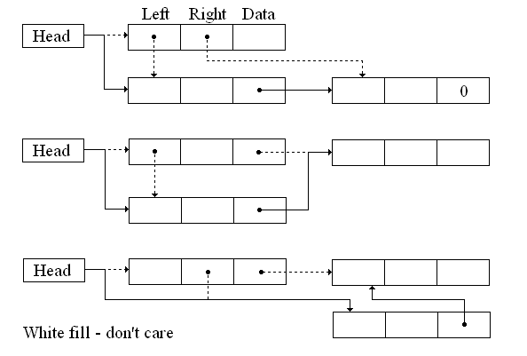
Figure 5: After returning the first node
where there are two nonzero pointers

Notice there is no grey fill in Figure 5. As a node in the garbage pool ceases to be a child node its data area pointer is defined.

The last remaining case happens when all three pointers are nonzero. In this case, shown before and after in Figure 6, the first child pointer is copied into Head, the second child pointer is copied into the first child’s data area, and the third pointer is copied into the second child’s data area.

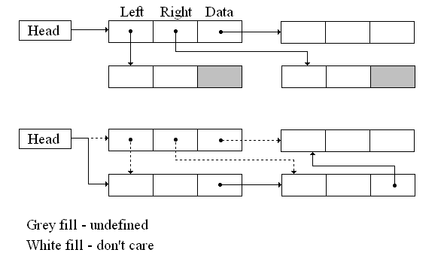
Figure 6: Before and after returning the first node
when there are three nonzero pointers

Those are the only possibilities when examining the three pointers in the node at the head of the linked list. Again, it becomes the returned node, and the list is relinked around it in an appropriate manner. In terms of efficiency in reusing nodes, in the worst case only 3 pointers must be updated, and all three are available within one level of indirection. Garbage collection consists of updating only 2 pointers to add any sized subtree to the pool of available nodes. At no time is it necessary to be concerned with or traverse any of the subtrees for node collection or reallocation.

The Demonstration Program
The goal of the demonstration program, other than to make it utilize this algorithm, was to light up the OLED display and to use the button and thumbwheel on the evaluation board. To this end a virtual binary tree with 63 nodes was envisioned, with 5 levels and 32 leaves on the 5th level. This is the limit of the 16x96 display without scrolling.

Figure 7 shows a color drawing of the full tree as displayed, although of course the colors are not present on the OLED display (any color you want as long as it’s green). The nodes are shown as red pixels and branches as black horizontal lines, with the leaves across the bottom (5th) level.

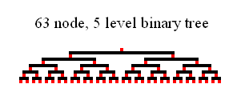
Figure 7: Tree as display by program (plus color)
Nodes are red, leaves are across bottom

Initially the node allocation number is set to 63 and a node is requested. The allocator creates the 63 nodes, puts 62 into the garbage pool, and returns 1. That node is then returned to the garbage pool and the allocation number is set to zero. In this application a request to allocate space for 0 nodes or a malloc() failure are fatal errors, and a distinctive pattern is shown on the display followed by an endless loop.

Once the nodes are created, the tree is emptied and an endless loop is started. Construction and destruction phases are alternated, with the thumbwheel setting determining the delay time between the phases (about 1/60th to 3 seconds). The resulting tree at the end of each phase is displayed.

In the construction phase, one of the 32 leaves is randomly selected, and the tree is traversed and/or constructed down to and including that leaf. In the destruction phase, one of the 63 nodes is randomly selected. If that node exists, it is discarded, along with its subtree. If it has no sibling, its parent is also discarded, recursively. Holding the pushbutton in inhibits the destruction phase, allowing for the (temporary) construction of a more robust tree.

Two numbers are also displayed, the left side number being the number of nodes in the tree and the right side number being the number of nodes in the garbage pool. These numbers should always add to 63, and are calculated using the brute force method of traversing each structure.

Some of the code was borrowed from the evaluation kit distribution application, including the random number generator, the ADC interrupt handler (partial), and the system configuration initialization. This amounts to a little over one page of a twelve page listing.

The Bottom Line
Development of this project was straight forward, being a software application only. As mentioned the algorithm had been developed over 30 years ago and was wandering around in the recesses of the author’s awareness. When the original project envisioned for this contest ran into some technical setbacks it was fairly easy to pull this one together in the short time remaining.

The winner of the “How long did I spend on that?” award for this entry goes to the necessity of setting the heap size manually. Once that little trick was discovered, the stack size (also manually set) was adjusted prior to having to learn it through hard knocks, given that the program makes several uses of recursion.

Again, this is a trivial use of the power of the evaluation kit, although the algorithm is valid for any binary tree application. It can also easily be extended beyond binary trees to other related data structures. It may even be more useful on embedded systems with more limited memory resources than on PCs and larger machines.

The author enjoyed his first encounter with the Stellaris LM3S811 Evaluation Kit, and learned much, so all in all he considers this a successful endeavor.

Photograph of Project

This being a software project demonstrating a binary tree node allocation/recovery algorithm, there were no modifications or hardware additions to the LM3S811 Evaluation Board.

In the photograph the display shows a 47 node binary tree, with the root at the top center, and several 5th level leaves along the bottom edge. There are 16 nodes in the garbage pool available for allocation. The 5 level tree can have a total of 63 nodes.

The potentiometer controls the speed of updates, ranging from about 1/60th of a second to 3 seconds per pause. A bottom level leaf is randomly added (if it doesn’t exist), then a pause, then a random node and its descendents is removed (if it exists), then a pause. Pressing the user button inhibits the destruction half of the cycle, so the tree rapidly builds to completion.

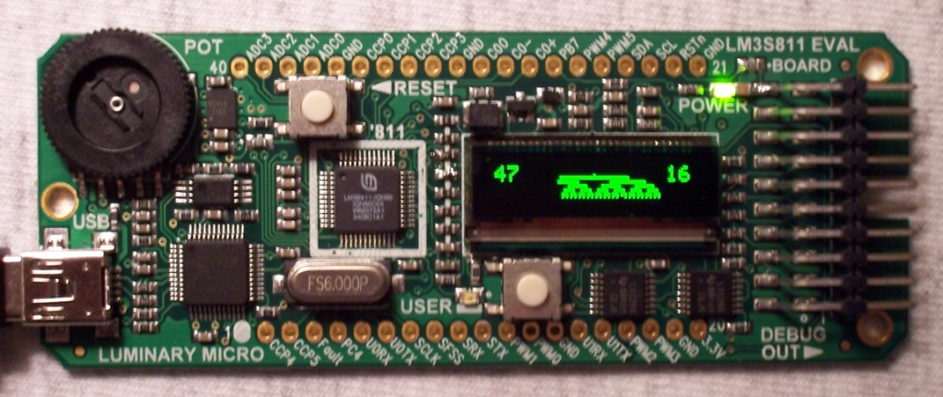

Block Diagram

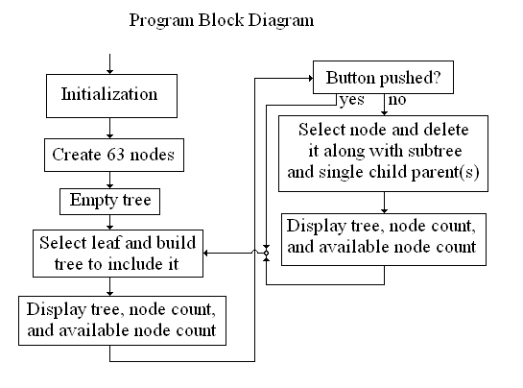

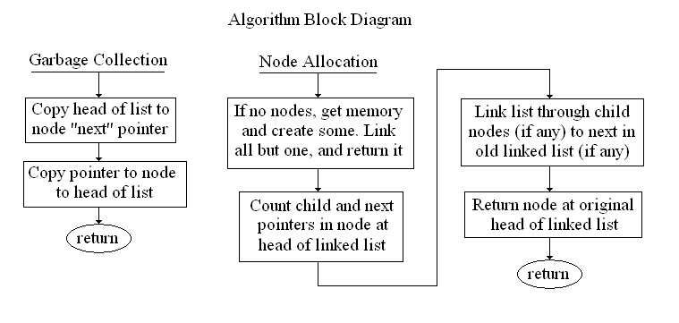

Schematic

There was no additional hardware other than that supplied on the LM3S811 Evaluation Kit board.

